Broadway Early Learning Center Supply List 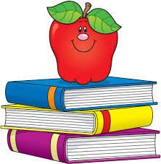
- 1 box gallon size Ziplock bags
- 1 bottle Elmers Glue
- 2 packages of small, sturdy paper plates
- 3 boxes 5oz paper cups
- 1 package of paper napkins
- 2 pkgs. CLOROX disinfecting wipes
- 1 16oz bottle of PURELL Hand Sanitizer
- 2 boxes Kleenex
- 2 pkgs. 24 count Crayola Crayons
- 4 boxes of nonperishable snacks (without nuts)
- 2 packages of baby wipes for classroom
- Diapers or Pull-ups, and wipes for your child, if not yet potty trained
- 1 bottle Crayola Washable Paint
- 1 package Crayola Washable Markers
- 1 pkg. Playdoh
- 1 pack bubbles
- 1 backpack

These are classroom wish list items that are not required; however, if you are able to donate, it is greatly appreciated:
- Paper Bowls
- Plastic Spoons
- Pre‐sharpened Colored Pencils
- Cotton balls
- Cotton swabs
- Clear contact paper
- Case water bottles
*LONGVIEW SCHOOL DISTRICT ONLY ALLOWS THESE SPECIFIC BRANDS: CLOROX & PURELL. THANK YOU.

